DUFF Needs YOU!
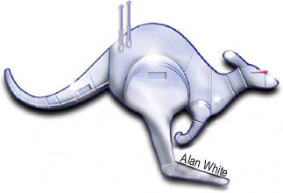
Are you a fan who would like to represent Australasia at the North American Science Fiction Convention (NASFiC) in 2009?

Do you know a fan who deserves to go to the North American NASFiC in 2009?

The Down Under Fan Fund is seeking nominees to head to North America in 2009.

But hurry! Nominations close on February 25th, 2009. You can find full details about DUFF and nomination requirements at http://sffanz.sf.org.nz/duff/ . You can also contact the Australasian administrator, Norman Cates, by writing to P.O. Box 13-574, Johnsonville, Wellington, New Zealand

